**Term Project Report (Computer Graphics)**

**On**

**Tic-Tac-Toe game using Directx and C++**



**Department of Computer Science & Engineering**,

**National Institute of Technology, Silchar­­­­­­­­**

**Under the guidance of** **Submitted by**

Mr. Badal SoniPiyush Sarawagi (13-1-5-015)

Shubham Kumar (13-1-5-077)

 **Department of Computer Science & Engineering,**

**National Institute of Technology, Silchar­­­­­­­­ (Assam)**

**Silchar Assam-788010**

______________________________________________________________

**CERTIFICATE**

This is to certify that the project entitled, “**Tic-Tac-Toe game using Directx and C++”** pertaining to the project undertaken by the following students of Computer Science and Engineering in partial fulfillment for the 4th semester Computer Graphics Project in Computer Science and Engineering of National Institute of Technology, Silchar.

Piyush Sarawagi (13-1-5-015) ………………………………….

Shubham Kumar (13-1-5-077) ………………………………….

Project Guide

Mr. Badal Soni ………………………………….

Dept. Of CSE

NIT Silchar

Date:

Place:

**ACKNOWLEDGEMENT**

Doing projects is a golden opportunity for learning and self –development. We consider ourselves very lucky and honoured to have so many wonderful people lead me through in completion of this project.

We would like to express my sincere gratitude to the BadalSoni Sir, who was our guide during the course of the project and who in spite of being extraordinarily busy with his duties, took time out to hear, guide and keep us on correct path and allowing us to carry out our project work. We would not hesitate to add that this short span of time completing this project added a different facet to our life.

Lastly We will like to thank our family and friends for their support and all others who made this project successful either directly or indirectly.

Shubham kumar(13-1-5-077), PiyushSarawagi(13-1-5-015)

C.S.E

**ABSTRACT**

Project : “Tic Tac Toe Game using DirectX SDK and C++”. The project is about a basic Tic Tac Toe game which almost all of us have played. It consists of various functionality offered by the application, associated features, platforms used and methodology followed by the application. The report also has class diagram and sequence diagram to emphasize further about the application have actually built and a way forward to summarize the task to be done further for this.

Project :

1. Introduction……………………………………………………… 4
2. Project Description…………………………………………… 4-6
   1. Application Software
   2. Application working details
3. Objective…………………………………………………………… 7
4. Functionality……………………………………………………… 7
5. Platform……………………………………………………………. 7
6. Overview…………………………………………………………... 8
7. Requirements……………………………………………………. 8

Summary…………………………………………………………………… 9

References………………………………………………………………… 9

1. **INTRODUCTION**

This project mainly concentrates about developing a game which will let a user to play with CPU. The developed application is a console application which receives user input and analyse it and declares the winner.

**2. Project Description**

Tic Tac Toe is a pencil and paper game for two players, X and O, who take turns making the spaces in a 3x3 grid. The player who succeeds in placing three respective marks in a horizontal, vertical or diagonal row wins the game.

**2.1 Application Software** is all the computer software that causes a computer to perform useful tasks beyond the running of the computer itself. A specific instance of such software is called a software application or easy to use applicaton.

This project is a game program. This game uses left,right,up,down key present on keyboard to control player. In each turn player click enter on the grid they want to capture and hence completes their move.

CPU uses X’s and moves first and player uses O’s to play the game and a player wins the game if he/she succeed in placing three respective marks in a horizontal, vertical or diagonal row.

Program Structure:

At the time when program starts, we initialize variables, and we run the game loop until the game ends or user closes the program.

The game consists of three steps:

* Display Grid
* Get and analyse players move
* Check for game end

Game Initialization:

First of all, we need to define a window for our game to run on. These bunch of codes below,initializes and creates the frame for us so that, we can run our program.

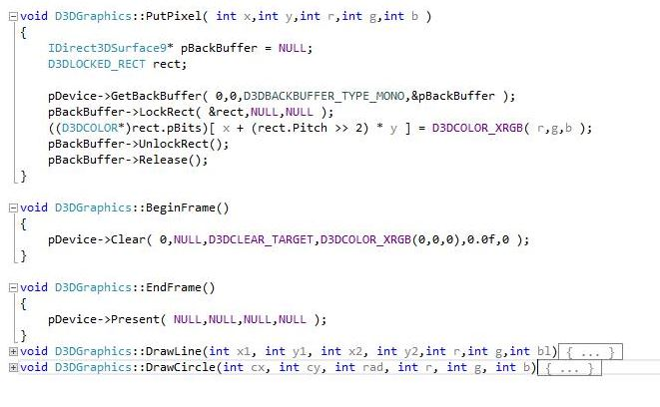

Then, after successful creation of the window, next we need to initialize our variables so that they can be accessed and used by the main program. Bunch of codes below shows the variable initialization that are required by the program.

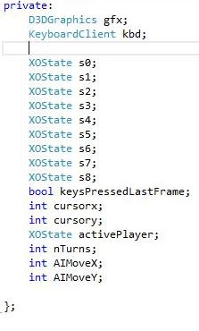

After that we define our functions that will be used in our program.

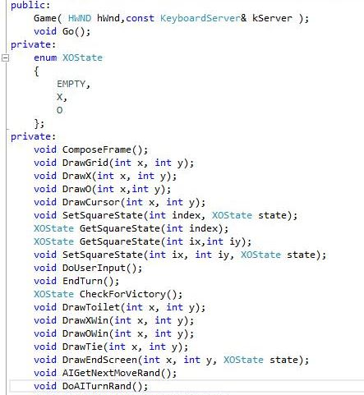

And lastly, we make those previously defined functions which completes our program.

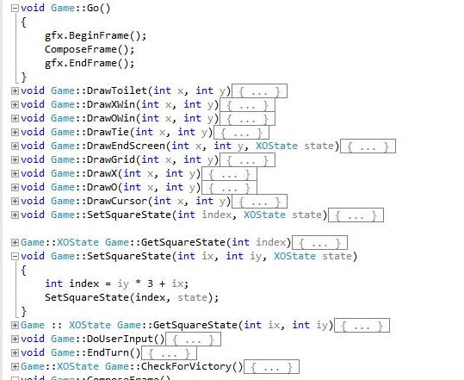

**3.OBJECTIVE**

3.1 User Friendly

Main objective of this project is to develop a user friendly and a single player game that anybody can play and enjoy.

3.2 Easy implementation

Our project uses c++ libraries which can be obtained under any visual c++ distribution. It also uses DirectX, which comes preinstalled with most of the windows operating system.

3.1 Combination of different functionalities

Using different applications that are easy to use and implement reduces complexity and increases the viability and vitality of program. This way it becomes easier to implement.

**4. FUNCTIONALITY**

* Generation of a window with tic tac toe grid.
* Analyzing the moves of opponent and countering it with it’s own move.
* Giving the end results in case of win, loss or tie.
* Allowing user to control the interface.

**5. PLATFORM**

* Can run on any Windows pc
* Can also run on various DirectX simulators.
* Can be run on Linux using Wine-devel

**6. OVERVIEW**

This application has been developed using C++, DirectX SDK and chili framework. Application has a tic tac toe grid with which user can interact and play against computer. When users inputs his value pc then inputs it’s own value and at the end of game it shows whether this game resulted in win, loss, or draw for the user.

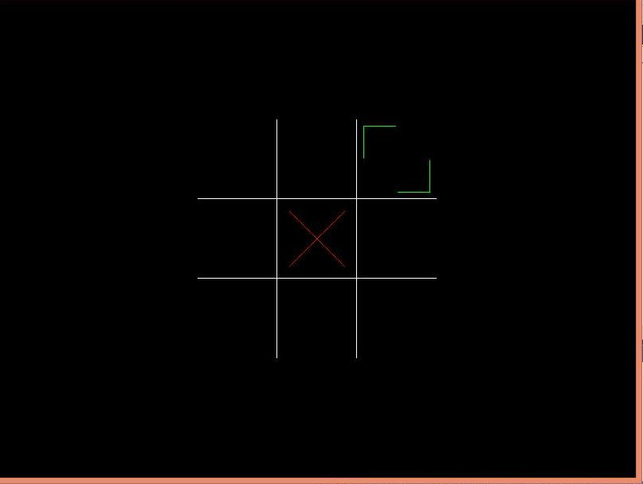Figure: Screenshot of Game

**7. REQUIREMENTS**

* DirectX 9.0 or later
* Visual Studio for compiling ( from source code)
* C++ libraries
* DirectX SDK

**Summary**

This project utilizes various tools inorder to be compiled and executed. Overall, This is a simple application which can be run on any operating system and can be played and enjoyed by anyone. It is open to development so everybody is welcome to download the source code and develop it further like adding new feature in it which will enable 1 human player to compete against CPU. Further suggestions are welcome regarding this project on it’s development aspects.

**References**

* Chili framework : [www.planet**chili**.net](http://www.planetchili.net)
* DirectX SDk : <https://www.microsoft.com/en-in/download/details.aspx?id=6812>
* Visual Studio: [https://www.**visualstudio**.com/](https://www.visualstudio.com/)
* Source code of our project can be downloaded from: <http://www.4shared.com/zip/MYLunKZWba/project.html>
* Project Presentation : <http://prezi.com/_7u38-blfgjy/present/?auth_key=f3jf0n4&follow=vz0korex3t3q>